Automobile Insurance Fraud Detection
Insurance is made to provide a relief amount for any damage caused. Insurance is a means of protection from financial loss, but now-a-days Many people are claiming the Insurance by fraud. It can be called a scam. It is called a fraud claim when a claimant attempts to obtain some benefit or advantage they are not entitled to, or when an insurer knowingly denies some benefit that is due. These types of Insurance claims cause loss to the company. So, It is necessary to detect the claims that are fraudulent. The number of cases of insurance fraud that are detected is much lower than the number of acts that are actually committed. So the main purpose of the Insurance Fraud Detection system is to predict whether an Insurance claim is a Fraud or a legal claim based on the different appeals and parameters.
Problem Statement : Automobile Insurance Fraud Detection
Machine learning is used to analyze vehicle damage details, claim amounts, and customer history.
The system identifies suspicious auto insurance claims and classifies them as fraud or genuine.
This helps insurance companies reduce financial losses and speed up claim processing.

Project Workflow:
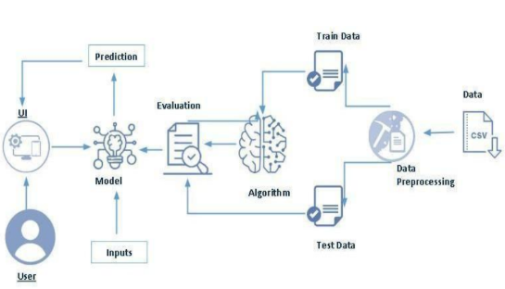

Business Requirement
A automobile insurance fraud detection project can have a variety of business requirements, depending on the specific goals and objectives of the project. Some potential requirements may include:
Accurate and up-to-date information: The project should use the most recent and reliable insurance claims data to detect fraud patterns, ensuring the information is accurate and relevant to current fraudulent behaviors.
Flexibility: The fraud detection system should be flexible and able to adapt to new fraud patterns, vehicle types, and changing claim behaviors as they emerge over time.
Compliance: The project should comply with all relevant laws and regulations, such as IRDAI guidelines, GDPR data privacy laws, and internal audit requirements for insurance companies.
User-friendly interface: The fraud detection system should be easy to use and understand for both claims adjusters and insurance managers, with clear risk scores and flagged claim summaries.

Literature Survey:
Ref. | Authors & Year | Paper Title | Methodology | Dataset Used | Key Results | Limitations | Research Gap Identified
[1] | Abdallah et al. (2022) | Fraud Detection in Auto Insurance Using Machine Learning | Random Forest, XGBoost, Logistic Regression | Auto insurance claims dataset (30,000 records) | XGBoost achieved 94.2% accuracy; Random Forest 91.8%; key features: claim amount, accident type, policy history | Dataset limited to single geographic region; class imbalance not fully addressed | Need for real-time fraud scoring and multi-region generalization
[2] | Subudhi & Panigrahi (2020) | Use of Optimized Fuzzy C-Means Clustering & SVM for Auto Insurance Fraud Detection | Fuzzy C-Means Clustering + SVM Hybrid | Vehicle insurance claims (UCI ML Repository) | Precision: 96.4%, Recall: 93.1%; outperformed standalone SVM by ~5% | High computational cost; sensitivity to initial cluster centers | Scalability to large streaming datasets not evaluated
[3] | Jiang et al. (2021) | Insurance Fraud Detection: Evidence from Artificial Intelligence and Big Data | Deep Neural Network (DNN), SMOTE for balancing | Chinese auto insurer claims (50,000+ records) | AUC of 0.97; SMOTE improved minority class recall from 61% to 88% | Feature engineering heavily manual; limited interpretability of DNN | Explainability (XAI) integration needed for regulatory compliance
[4] | Bauder & Khoshgoftaar (2018) | Medicare Fraud Detection Using Machine Learning Methods | Decision Tree, Naive Bayes, AdaBoost, RF; imbalance handled via sampling | CMS Medicare provider claims data (public) | AdaBoost: 97.1% accuracy; F1-score 0.95 on fraud class | Binary classification only; not applicable to multi-type fraud | Multi-class fraud taxonomy and cross-insurance domain adaptation
[5] | Severino & Peng (2021) | Application of Machine Learning Algorithms to Vehicle Insurance Fraud Detection | LightGBM, CatBoost, ensemble stacking with feature importance analysis | Kaggle vehicle insurance fraud dataset (15,420 records) | LightGBM: 95.6% accuracy, ROC-AUC 0.98; ensemble stacking improved F1 by 2.3% | Limited to structured tabular data; ignores textual claim notes | NLP integration for unstructured claim narrative analysis

Social or Business Impact
Social Impact: Improved policyholder trust: By accurately detecting fraudulent claims, genuine claimants experience faster and fairer settlements, reducing the financial burden on honest policyholders caused by inflated premiums due to fraud.
Business Impact: Reduced financial losses: By automatically identifying and flagging suspicious automobile insurance claims, the system directly reduces payouts on fraudulent claims, improving the insurer's loss ratio and overall profitability.

